标题：Predictive Three-Dimensional Printing of Spare Parts with Internet of Things
作者及机构:
Jing-Sheng Song: Fuqua School of Business, Duke University, Durham, North Carolina 27708
Yue Zhang: Smeal College of Business, Pennsylvania State University, University Park, Pennsylvania 16802
摘要: Industry 4.0 integrates digital and physical technologies to transform work management, where two core enablers are the internet of things (IoT) and three-dimensional printing (3DP). IoT monitors complex systems in real time, whereas 3DP enables agile manufacturing that can respond to real-time information. However, the details of how these two can be integrated are not yet clear. To gain insights, we consider a scenario where a three-dimensional (3D) printer supplies a critical part to multiple machines that are embedded with sensors and connected through IoT. Although the public perception indicates that this integration would enable on-demand printing, our research suggests that this is not necessarily the case. Instead, the true benefit is the ability to print predictively. In particular, it is typically more effective for the 3D printer to predictively print to stock based on a threshold that depends on the system’s status. We also identify a printing mode called predictive print on demand that allows for minimal inventory, and we find the speed of 3DP to be the primary factor that influences its optimality. Furthermore, we assess the value of IoT in cost reductions by separately analyzing the impact of advance information from embedded sensors and the real-time information fusion through IoT. We find that IoT provides significant value in general. However, the conventional wisdom that IoT’s value scales up for larger systems is suitable only when the expansion is paired with appropriate 3DP capacity. Our framework can help inform investment decisions regarding IoT/embedded sensors and support the development of scheduling tools for predictive 3DP.
AI标题: 工业4.0生产革命：物联网驱动3D打印预测性备货最优解
AI精炼: 这篇论文聚焦工业4.0中的物联网（IoT）与3D打印（3DP）技术融合，探索如何通过实时数据优化关键备件的预测性生产调度。传统研究多孤立分析传感器监测或按需打印策略，但未能解决两者协同下的动态决策难题——例如，现有文献假设需求外生或忽略打印容量限制，导致实际应用中库存与响应效率失衡。作者提出创新性的“智能系统”模型：通过IoT实时监控多设备零件老化状态，建立基于系统寿命状态的动态基准库存策略。研究发现，最优策略并非单纯按需打印，而是根据设备整体健康度预测性备货（print to stock），仅当3D打印速度足够快时，零库存的预测性按需模式（predictive print on demand）才适用。研究还通过构建“被动系统”（无IoT）和“主动系统”（仅局部传感器）作为对照组，量化了IoT的价值——其核心贡献60%来自传感器提供的预警信息，40%源于IoT实现的全局数据融合。数值实验表明，3D打印速度是决定模式选择的首要因素（速度提升可使预测按需模式适用性从16.7%跃升至92.7%），而盲目扩大监控规模若不匹配打印容量，反而削弱IoT效益。该框架为制造业投资IoT/传感器提供了量化决策工具，并可扩展至生物打印等实时响应场景。
关键词:
智能系统模型
系统寿命状态监控
动态基准库存策略
预测性打印到库存
Erlang分布建模
物联网实时信息融合
嵌入式传感器预警机制
数字孪生调度
学术要点: 学术要点 1：预测性按需打印（Predictive Print on Demand）|||
一种基于系统状态的最小库存打印模式，通过物联网实时信息提前触发打印任务以匹配即将产生的备件需求。|||
学术要点 2：系统生命周期状态（System Lifetime Status）|||
通过物联网融合多设备传感器数据形成的多维状态向量，表征所有在用零件的寿命阶段分布，作为预测性打印决策的核心依据。|||
学术要点 3：内生需求动态（Endogenous Demand Dynamics）|||
备件需求与库存可用性之间的双向耦合关系：设备故障产生的需求直接影响打印决策，而打印策略又反作用于设备运行状态。|||
学术要点 4：上界系统框架（Upper-Bound System Framework）|||
通过引入应急备件借贷机制构建的分析模型，将内生需求转化为外生需求流，为复杂生产-库存系统提供策略结构解析方法。|||
学术要点 5：信息结构价值分解（Value Decomposition of Information Structures）|||
通过基准系统对比量化物联网价值，分离嵌入式传感器的预先信息价值与物联网实时信息融合价值，揭示不同信息维度的成本节约机制。
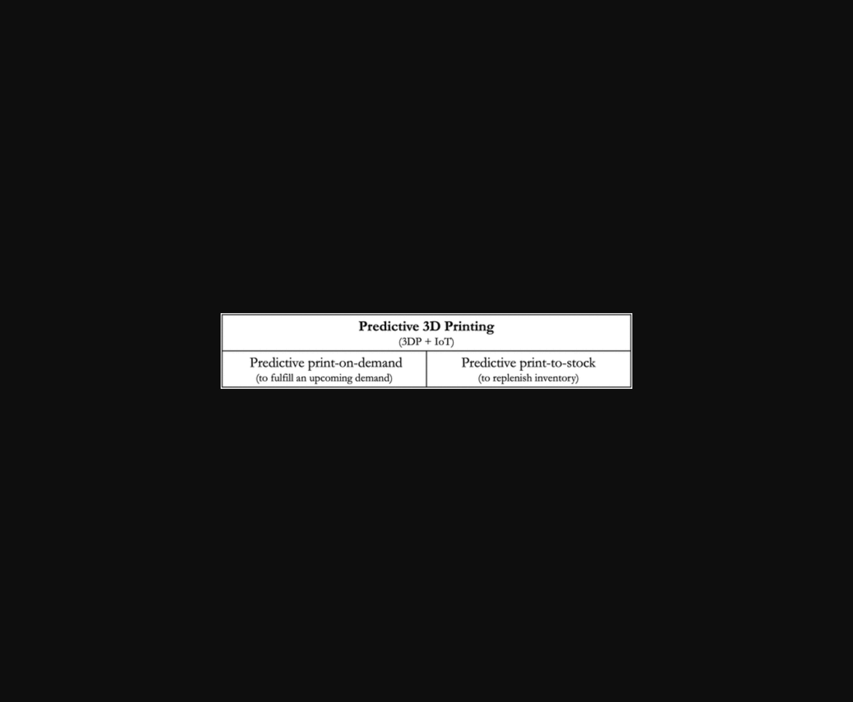
图片展示了物联网监控下3D打印机与生产设备间的预测性打印逻辑及库存阈值决策机制。

图片展示了3D打印机与物联网设备协同实现预测性制造的系统架构。
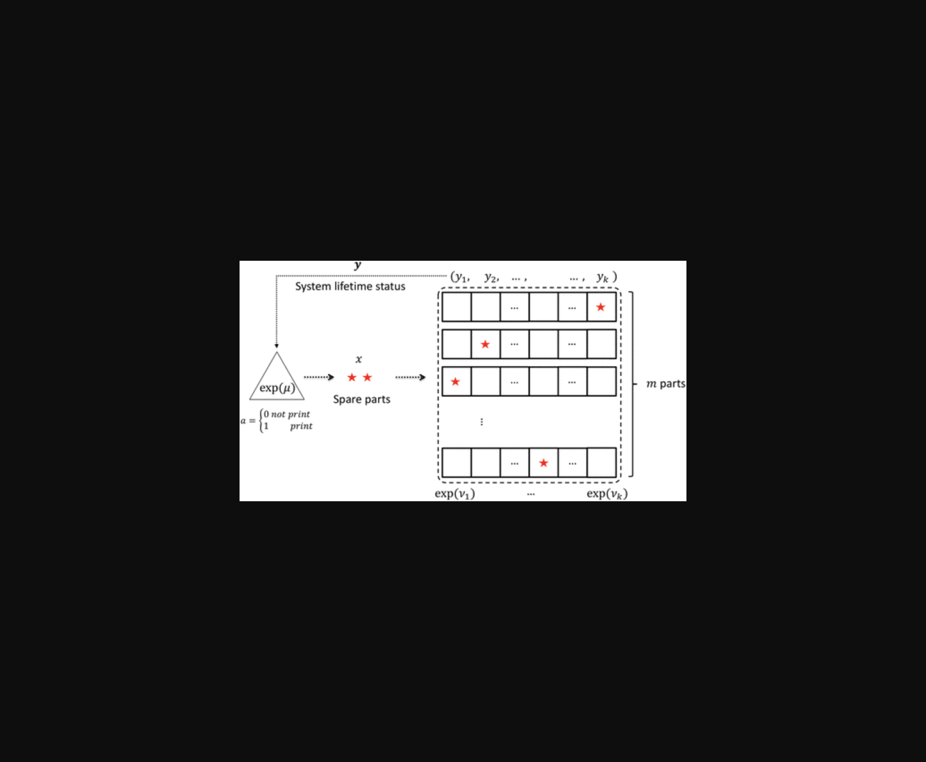
示意图展示了3D打印机通过物联网监测设备状态进行预测性补货的运作模式。
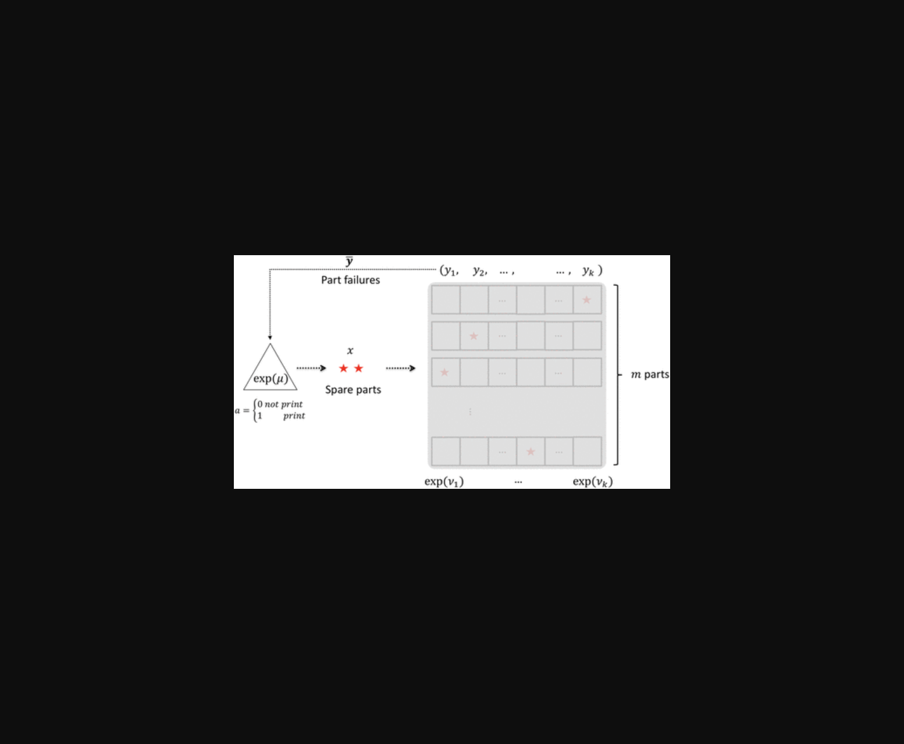
图片展示了基于物联网的3D打印生产系统模型，涉及库存阈值与多设备协同机制。
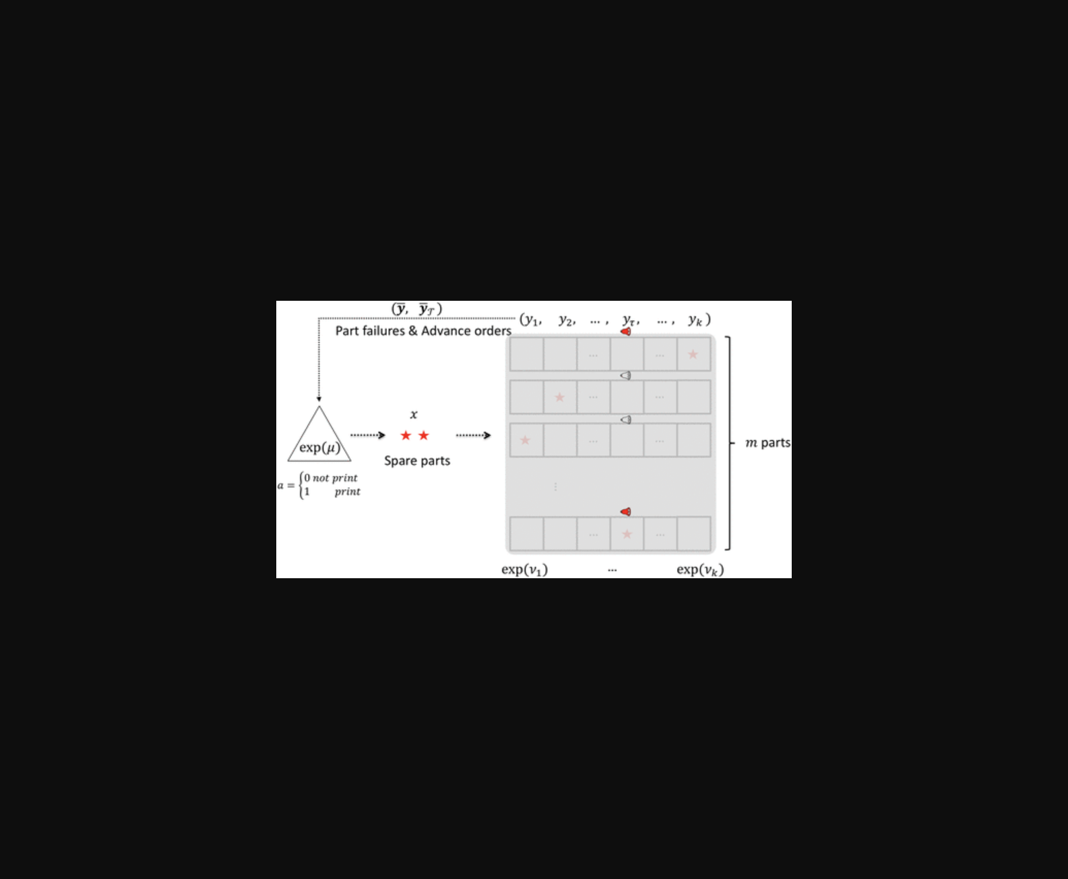
图片展示了物联网连接的3D打印机与生产设备间的协同运作模式，重点呈现预测性打印与实时信息融合的机制。
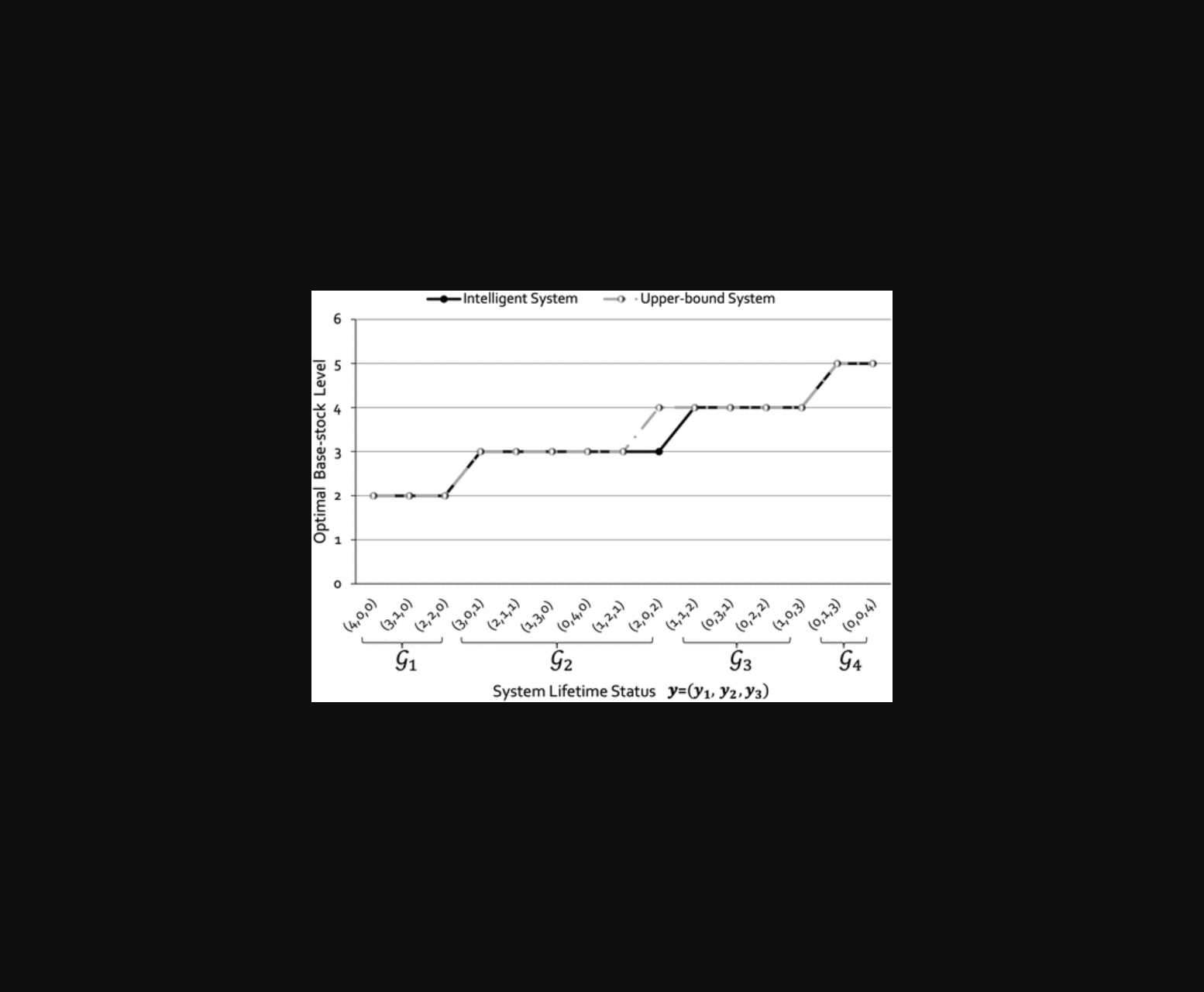
该图展示了基于物联网监测的3D打印预测性生产系统模型。
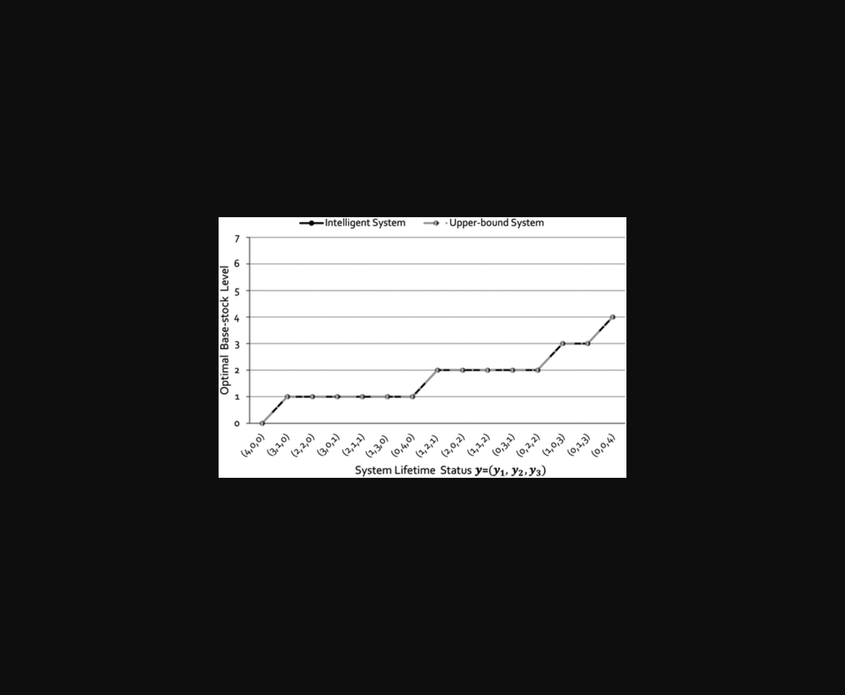
图片展示了物联网传感器数据驱动3D打印机进行预测性生产的系统框架。
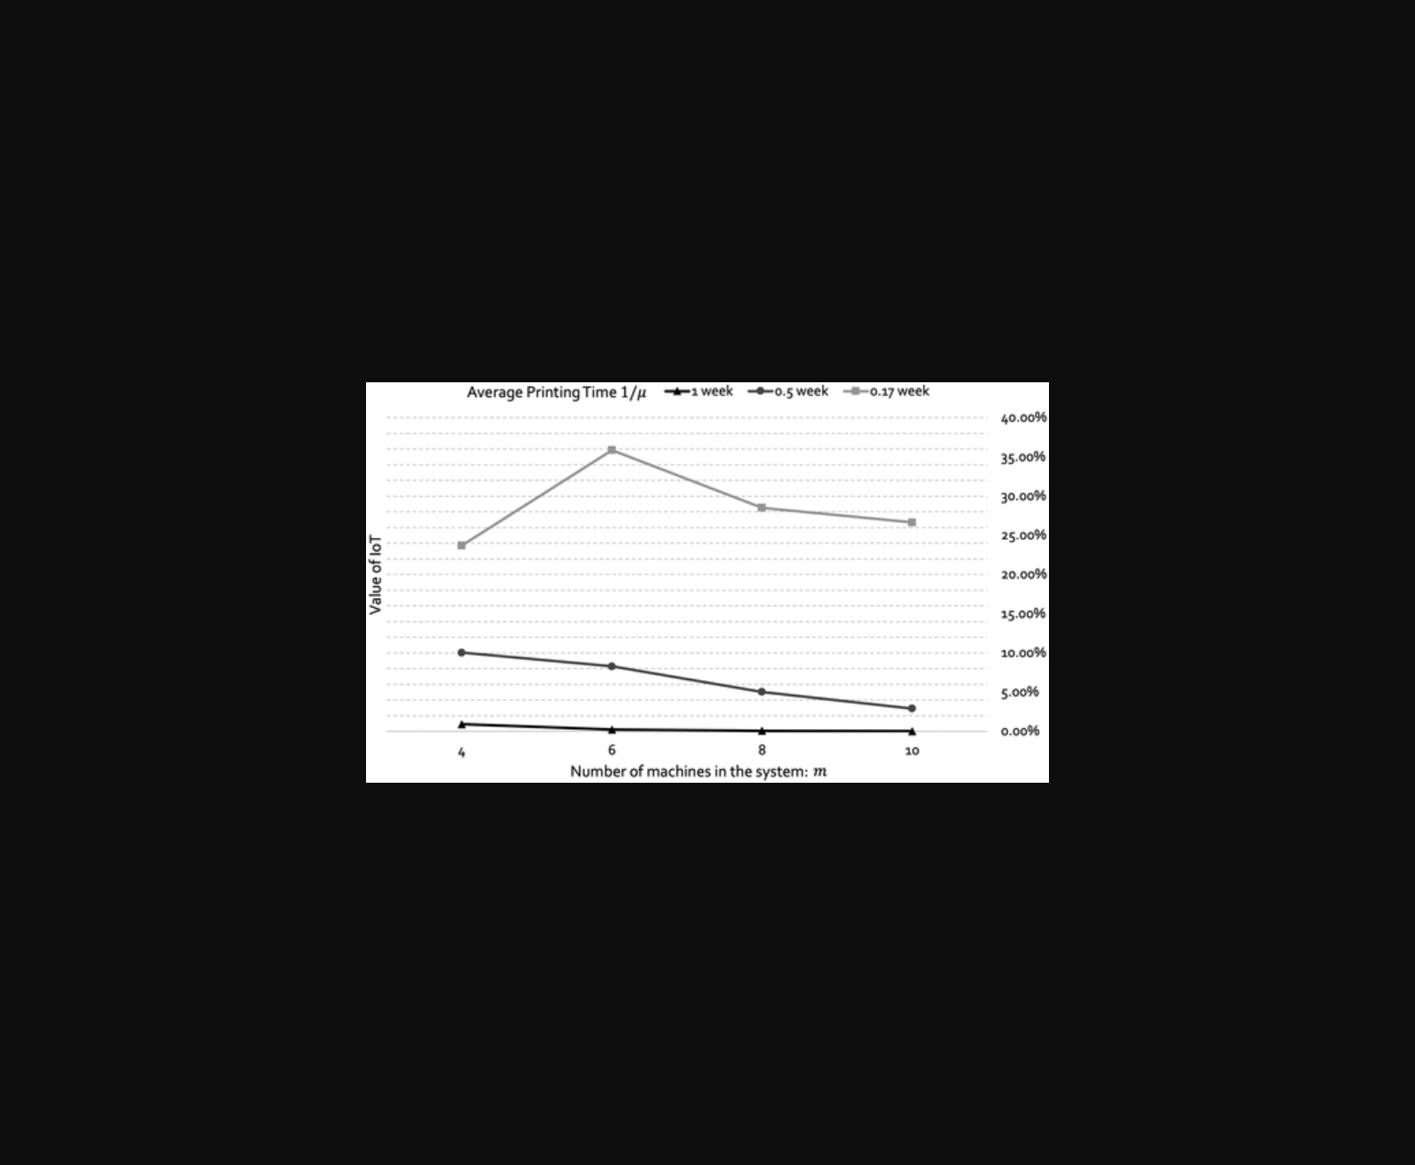
该图展示了基于IoT监测的3D打印机预测性补货策略与库存阈值关系。
原文链接: https://doi.org/10.1287/mnsc.2023.00978

